**BACHELOR OF ENGINEERING**

**SMART DUSTBIN**

**USING**

**INTERNET OF THINGS**

**SUBMITTED BY**

ASHISH JHA

1810992051

NIKHIL RAWAL

1810992061

HARMANDEEP SINGH

1810992039

KANWARDEEP SINGH

1810992056

RIPANJEET SINGH SIDHU

1810992069

GUNINDER PAL SINGH

1810991928

Department of Computer Science and Engineering

**Supervised by**

Dr. Saira Banu

Associate Professor

CURIN



**CHITKARA UNIVERSITY INSTITUTE OF ENGINEERING & TECHNOLOGY**

**CHITKARA UNIVERSITY**

PUNJAB, INDIA (12pt.)

December, 2019

**ABSTRACT**

Of late positive steps are taken to boost the level of cleanliness in our country. People are getting more effective in taking all the possible steps to clean their neighborhood. Various actions are also introduced by the government to maintain cleanliness in the country. We have made a system which will notify the municipal corporations or the cleaners to empty the dustbin when the dustbin gets full. In this system, we have put an ultrasonic sensor with ESP8266 and Arduino on top of the dustbin which will sense the level of garbage in the dustbin according to the total height of the dustbin. When the garbage will reach a certain level, a notification and an email will be sent to the municipal corporation's office and the cleaners mobile so that the workers can take further actions to empty the dustbin. This system will support in cleaning our surrounding in a better way. By means of this system people do not have to check all the systems physically but they will get notified when the dustbin will get filled.

**INTRODUCTION**

IoT or Internet Things states to the system of linked physical things that can connect and interchange information between themselves without the need of any humanoid involvement. Anything in the corporal biosphere which can be provided with an IP address to allow information broadcast over a system can be made part of IoT scheme by implanting them with electric hardware such as sensors, software and networking equipment. IoT is dissimilar to Internet as in a technique it rises above Internet connectivity by allowing ordinary things that uses implanted circuits to relate and interconnect with each other by means of the present Internet set-up.

The room of IoT has full-fledged enormously as now it comprises of further than 33 billion associated devices and conferring to the specialists it will upsurge to 50 billion by the termination of 2020. With the arrival of IoT manufacturers and clients have benefited mutually. Producers have increased vision into how their goods are used and how they accomplish out in the actual biosphere and upsurge their profits by giving value added services which improves and extends the lifespan of their goods or facilities. Clients have the capability to assimilate and govern more than one device for a more modified and enhanced user experience.

In this report, we have to proposed a system for the instantaneous cleaning of the waste bin. As dustbin is measured as a rudimentary necessity to uphold the level of hygiene in the environment, so it is very significant to clean all the dustbins as quickly as they get full. We have used Arduino, Ultrasonic sensor and NodeMCU ESP8266 for this system. The sensor is placed on the topmost part of the dustbin which will support in transferring the data to the municipal office or to the cleaner that the level of trash has touched its determined level. Afterward this the dustbin should be emptied as quickly as possible. The impression of IoT when cast-off in this area, will affect in a healthier surrounding for the people to live in. No more unhygienic circumstances will arise in the surrounding. With the assistance of this system nominal quantity of smart dustbins can be used around the entire surrounding and the environment will still be much cleaner.

There has been an extraordinary evolution in the quantity of devices being linked to the Internet since previous few years. All these devices linked to the internet are portion of the IoT structure which can share information with each other. The IoT network comprises of implanted electronics, sensors and software that permits these devices to direct and accept data among themselves. This is why it is appreciated to use such an existing structure for scheming the proposed system. The shortcomings of the current system are that the personnel have to go and check the dustbins everyday whether they are filled or not, it consequences in high cost. If the dustbin does not get emptied on right time, the surrounding of dustbins becomes unsanitary and disease could blowout. The planned system will benefit in eradicating all these shortcomings. The instantaneous data can be gained concerning the level of the dustbin filled on the system itself. It will also assist in dropping the cost as the personnel will have to go only at that time when the bin is full. This will also aid in resource optimization and if the bins will be emptied at time then the surrounding will remain harmless and free from all kinds of illnesses. The environment will become more cleaner and the odors of the garbage will be fewer.

**PAPERS RELATED TO PROJECT**

* **GARBAGE MANAGEMENT SYSTEM FOR SMART CITY USING IOT**

**AUTHOR**: Saranya

Rajeshwari

Priyadharshini

Praveen Kumar.S.S

Pradeep.G

**PROJECT REFERENCE NO**.: ISSN(p): 1311-8080

ISSN(e): 1314-3395

**Link :** <https://acadpubl.eu/jsi/2018-118-20/articles/20a/80.pdf>

* **SMART DUSTBIN CONTAINER USING IOT NOTIFICATION**

**AUTHOR**: Shubhangi Thorat

Swati Kanase

Pooja Bhingardeve

**PROJECT REFRENCE NO.:** ISSN(e): 2395-0056

ISSN(p): 2395-0072

**DATE OF PUBLISHING:** 03 Mar 2019

**Link**: <https://www.irjet.net/archives/V6/i3/IRJET-V6I31314.pdf>

* **Smart Garbage Management System Using Internet of Things (IOT) For Urban Areas**

**AUTHOR:** Ms. Rupa

Ms. Rajni Kumari

Ms. Nisha Bhagchandani

Mr. Ashish Mathur

**PROJECT REFRENCE NO.:** ISSN (e): 2250-3021

ISSN (p): 2278-8719

**DATE OF PUBLISHING:** 05 May 2018

**Link**: <https://www.iosrjen.org/Papers/vol8_issue5/Version-1/I0805017884.pdf>

**PROPOSED IDEA**

In this report, we have to proposed a system for the instantaneous cleaning of the waste bin. As dustbin is measured as a rudimentary necessity to uphold the level of hygiene in the environment, so it is very significant to clean all the dustbins as quickly as they get full. We have used Arduino, Ultrasonic sensor and NodeMCU ESP8266 for this system. The sensor is placed on the topmost part of the dustbin which will support in transferring the data to the municipal office or to the cleaner that the level of trash has touched its determined level. Afterward this the dustbin should be emptied as quickly as possible. The impression of IoT when cast-off in this area, will affect in a healthier surrounding for the people to live in. No more unhygienic circumstances will arise in the surrounding. With the assistance of this system nominal quantity of smart dustbins can be used around the entire surrounding and the environment will still be much cleaner.

**COMPONENTS REQUIRED**

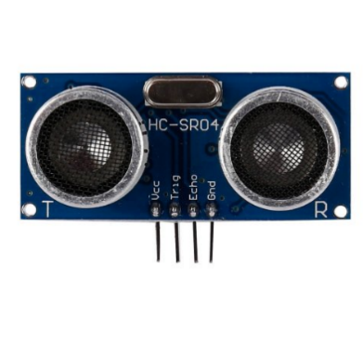

1. Ultrasonic sensor HC-SR04

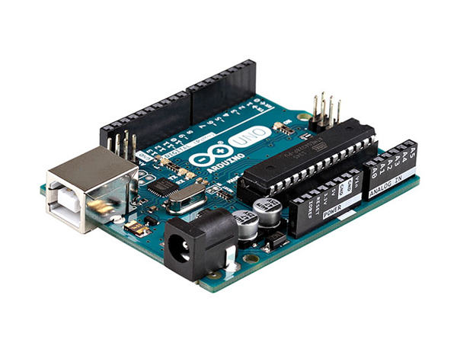

1. Arduino Uno

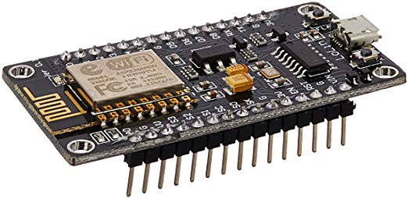

1. Node MCU ESP8266

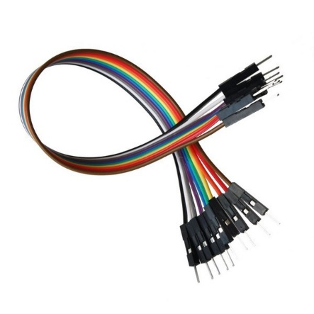

1. Connecting wires

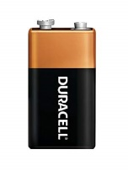

1. Battery

**WORKING**

Here is the complete working of IOT based Smart Dustbin.

**Steps of Operation**

**Step 1:** First of all, when we start the device name of project is displayed on screen that is “Smart Dustbin” and then device comes in event detection state.

**Step 2**: The device will remain in event detection state till the dustbin is not completely filled. In this state the Ultrasonic sensor HC-SR04 continuously detects the level of dustbin and keeps on transmitting the data to the Blynk application with is help of NodeMCU ESP8266 module.

**Step 3:** The Blynk app will keep on analyzing the data sent by HC-SR04 and when the data will cross certain limit it will trigger notification event.

**Step 4:** When the notification event will be triggered by the app the cleaners will get a notification on their phone telling them that the dustbin is full and needs to be emptied as soon as possible.

It will also send an email regarding the status of the dustbin to the workers and municipal corporation.

**Step 5:** After the dustbin is emptied the HC-SR04 will send a signal to the app and the device will again go into event detection state in which it was initially and same process is repeated according to the level of dustbin.

**Ultrasonic sensors** work by emitting sound waves at a frequency too high for humans to hear. They then wait for the sound to be reflected back, calculating distance based on the time required. This is similar to how radar measures the time it takes a radio wave to return after hitting an object.

While some sensors use a separate sound emitter and receiver, it’s also possible to combine these into one package device, having an ultrasonic element alternate between emitting and receiving signals. This type of sensor can be manufactured in a smaller package than with separate elements, which is convenient for applications where size is at a premium.

While radar and ultrasonic sensors can be used for some of the same purposes, sound-based sensors are readily available—they can be had for just a couple dollars in some cases—and in certain situations, they may detect objects more effectively than radar.

For instance, while radar, or even light-based sensors, have a difficult time correctly processing clear plastic, ultrasonic sensors have no problem with this. In fact, they’re unaffected by the colour of the material they are sensing.

On the other hand, if an object is made out of a material that absorbs sound or is shaped in such a way that it reflects the sound waves away from the receiver, readings will be unreliable.

If you need to measure the specific distance from your sensor, this can be calculated based on this formula:

Distance = ½ T x C

(T = Time and C = the speed of sound)

At 20°C (68°F), the speed of sound is 343 meters/second (1125 feet/second), but this varies depending on temperature and humidity.

Specially adapted ultrasonic sensors can also be used underwater. The speed of sound, however, is 4.3 times as fast in water as in air, so this calculation must be adjusted significantly.

Ultrasonic sensors work by sending out a sound wave at a frequency above the range of human hearing.  The transducer of the sensor acts as a microphone to receive and send the ultrasonic sound. Our [ultrasonic sensors](https://www.maxbotix.com/SelectionGuide/Selection-Guide.htm), like many others, use a single transducer to send a pulse and to receive the echo.  The sensor determines the distance to a target by measuring time lapses between the sending and receiving of the ultrasonic pulse.

The working principle of this module is simple.  It sends an ultrasonic pulse out at 40kHz which travels through the air and if there is an obstacle or object, it will bounce back to the sensor.  By calculating the travel time and the speed of sound, the distance can be calculated.

**Arduino** is a single-board microcontroller meant to make the application more accessible which are interactive objects and its surroundings. The hardware features with an open-source hardware board designed around an 8-bit Atmel [AVR microcontroller](https://www.elprocus.com/types-of-avr-microcontroller-atmega32-and-atmega8/)or a 32-bit Atmel ARM. Current models consists a USB interface, 6 analog input pins and 14 digital I/O pins that allows the user to attach various extension boards.

The Arduino Uno board is a [microcontroller based](https://www.watelectronics.com/8051-microcontroller-architecture/) on the ATmega328. It has 14 digital input/output pins in which 6 can be used as PWM outputs, a 16 MHz ceramic resonator, an ICSP header, a USB connection, 6 analog inputs, a power jack and a reset button. This contains all the required support needed for microcontroller. In order to get started, they are simply connected to a computer with a USB cable or with a AC-to-DC adapter or battery. Arduino Uno Board varies from all other boards and they will not use the FTDI USB-to-serial driver chip in them. It is featured by the Atmega16U2 (Atmega8U2 up to version R2) programmed as a USB-to-serial converter.

**NodeMCU** is an open source IoT platform. It includes firmware which runs on the ESP8266 Wi-Fi SoC from Espressif Systems, and hardware which is based on the ESP-12 module. The term "NodeMCU" by default refers to the firmware rather than the development kits. The firmware uses the Lua scripting language. It is based on the eLua project, and built on the Espressif Non-OS SDK for ESP8266. It uses many open source projects, such as lua-cjson.

As Arduino.cc began developing new MCU boards based on non-AVR processors like the ARM/SAM MCU and used in the Arduino Due, they needed to modify the Arduino IDE so that it would be relatively easy to change the IDE to support alternate toolchains to allow Arduino C/C++ to be compiled for these new processors. They did this with the introduction of the Board Manager and the SAM Core. A "core" is the collection of software components required by the Board Manager and the Arduino IDE to compile an Arduino C/C++ source file for the target MCU's machine language. Some ESP8266 enthusiasts developed an Arduino core for the ESP8266 WIFI SoC, popularly called the "ESP8266 Core for the Arduino IDE".[[16]](https://en.wikipedia.org/wiki/NodeMCU#cite_note-16) This has become a leading software development platform for the various ESP8266-based modules and development boards, including Node MCUs.

Check if dustbin is full

Detect the level of garbage

Start

NO

YES

Trigger Notification

Update status of dustbin

Send Notification

Send Email

**Fig(i). Sequence Diagram**

**CIRCUIT DIAGRAM**

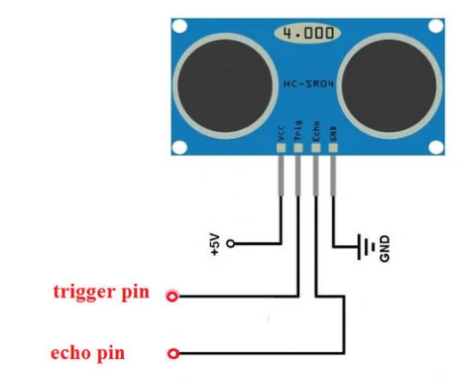

**FIG(ii). Ultrasonic sensor HC-SR04**

Ultrasonic sensor HC-SR04

Node MCU ESP8266

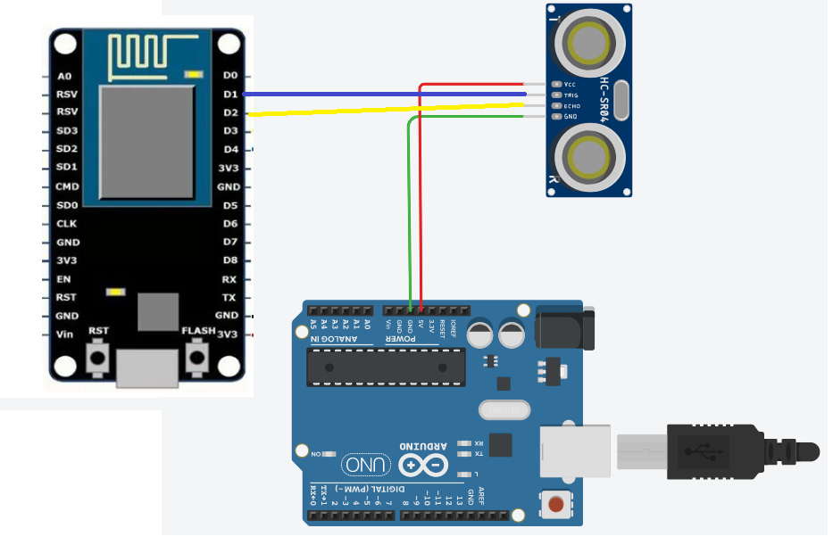

**Fig(iii). Circuit Diagram**

Arduino Uno

**CODING**

#define trigger 5

#define echo 4

#define BLYNK_PRINT Serial

#include <ESP8266WiFi.h>

#include <BlynkSimpleEsp8266.h>

char auth[] = "4pMgUxjM4vFyIXmYhCE4upWI1PhQjn54";

char ssid[] = "Samsung";

char pass[] = "ashishj@samsung";

void setup()

{

Serial.begin (9600);

Blynk.begin(auth, ssid, pass);

pinMode(trigger, OUTPUT);

pinMode(echo, INPUT);

}

void loop()

{

long duration, distance;

digitalWrite(trigger, LOW);

delayMicroseconds(2);

digitalWrite(trigger, HIGH);

delayMicroseconds(10);

digitalWrite(trigger, LOW);

duration = pulseIn(echo, HIGH);

distance = duration*0.034/2;

Serial.println(distance);

Blynk.virtualWrite(V0, distance);

//if (distance <= 5) {

// Blynk.virtualWrite(V0, 0);

/*}

if (distance >=6 && distance <=100 ) {

Blynk.virtualWrite(V0, 8);

}

if (distance <= 6) {

Blynk.virtualWrite(V1, 255);

}

else {

Blynk.virtualWrite(V1, 0);

}

if (distance <=3) {

Blynk.virtualWrite(V2, 255);

}

else {

Blynk.virtualWrite(V2, 0);

}*/

Blynk.run();

}

**SCREENSHOTS IMAGES**

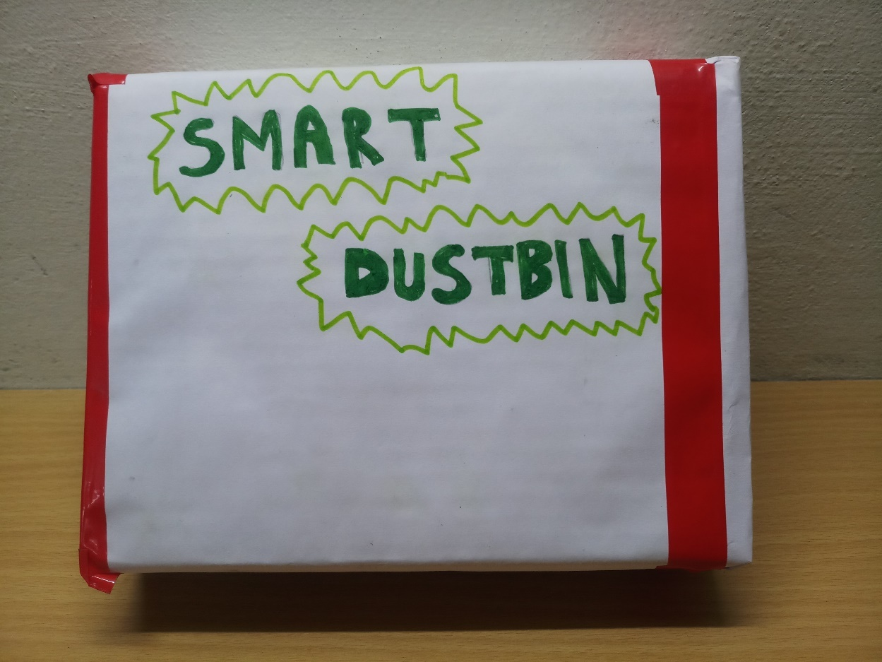

**FIG(IV). Back View**

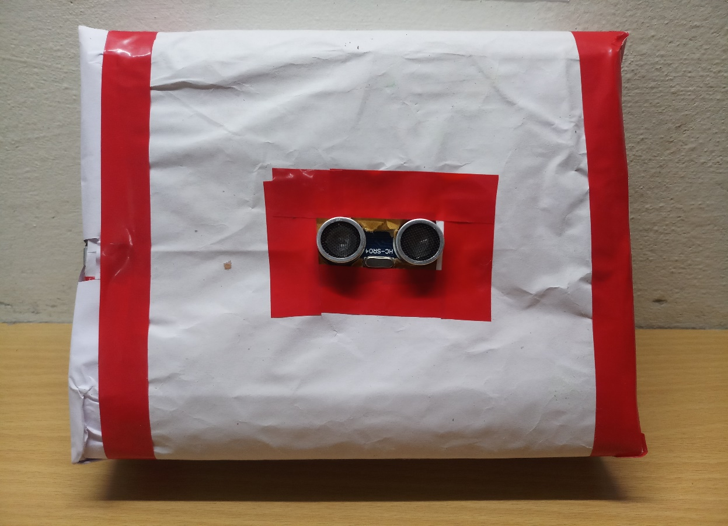

**FIG(V). Front View**

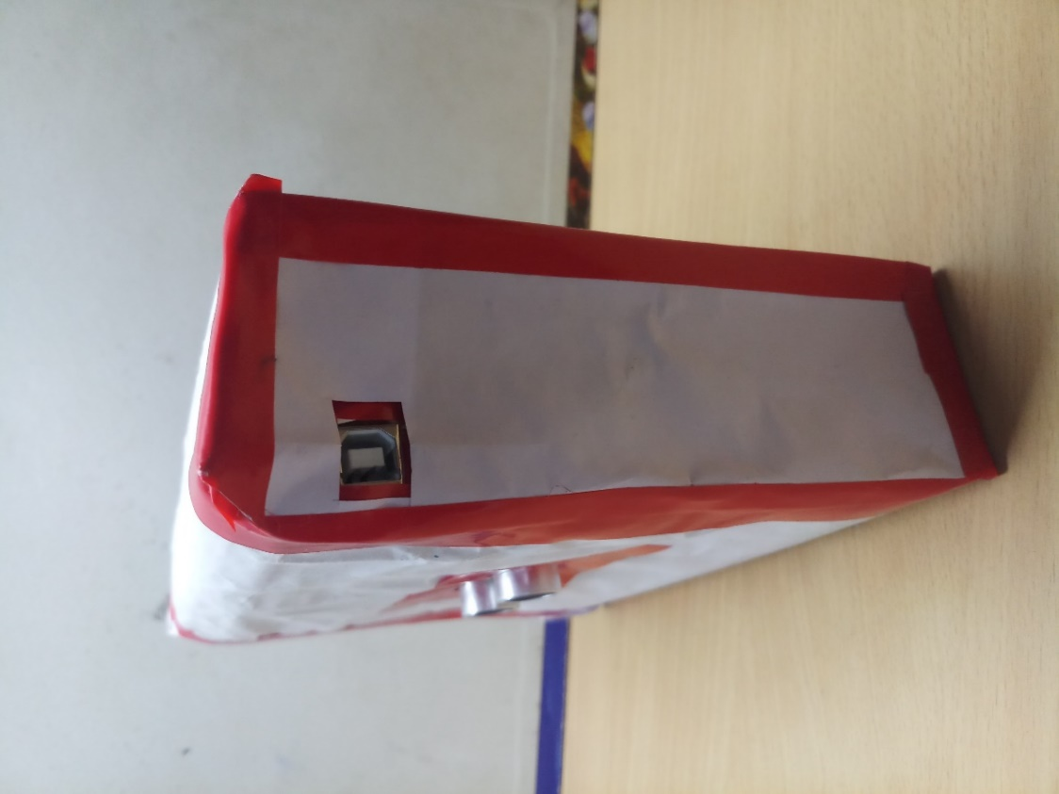

**FIG(Vi). Right Side View**

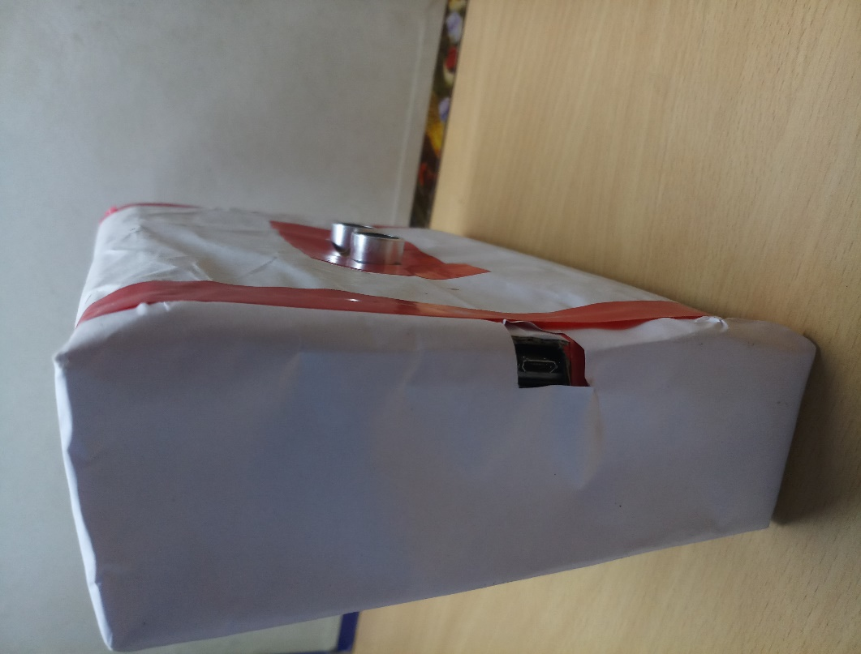

**FIG(Vii). Left Side View**

**CONCLUSION**

The main motive is to uphold the level of hygiene in the surrounding area and form an environment which is healthier for living. Using this system, we can continuously keep an eye the level of the garbage in the dustbins which are located in numerous parts of a place. If a specific dustbin has reached the determined level then the personnel can be updated and they can instantly take necessary actions to empty it as quickly as possible. The workers can check the status of these bins anytime on their mobile phones. This can prove to be a very beneficial system if used accurately. The system can be used as a standard by the people who are ready to take one step further for maintaining the sanitation in their areas. In this system we have used Ultrasonic HC-SR04 sensor to check the level of garbage in the dustbins but in upcoming time several other kinds of sensors can be used with the HC-SR04 to get more accurate result and to take this system to an upper level. Now this system can be used in certain zones but as soon as it evidences its reliability it can be used in all the big zones. As this system also decreases labor-intensive work firm changes can be done to the system to take it to a higher level and make it more beneficial for the workers and people who are using it. In future, a taskforce can be made which will be responsibile for management and upholding the system and also to upkeep its maintenances.